Website planning sheet:

Names for the site:

* BigFish

Main ideas

* New idea: food basis- a foodie compilation of the best restaurants in York no matter the time of day!
* Here at BigFish, we aim to demystify York’s food scene for locals and tourists by presenting our monthly food favourites in a clean and simple way. So, whether you’re after great cake and afternoon tea, or a warm dinner after a long day, we have the restaurants just for you!

Pages:

* A landing/Home page = index.html
* About us and contact us page
* Social media
* Breakfast-Lunch-Dinner pages (possibly dessert + Coffee too too?)
* You might also like…
* Search our site- button
* A bookmark function?
* Need to add a google map insert if possible
* Add a short blurb on York

RESTAURANTS

Websites used:

* Trip advisor: <https://www.tripadvisor.co.uk/Restaurants-g186346-York_North_Yorkshire_England.html>
* Time out: <https://www.timeout.com/york/restaurants/best-restaurants-in-york>
* The telegraph: <https://www.telegraph.co.uk/travel/destinations/europe/united-kingdom/england/yorkshire/york/articles/york-restaurants/>
* Culture trip: <https://theculturetrip.com/europe/united-kingdom/england/articles/york-s-10-best-cultural-restaurants-yorkshire-for-gourmets/>
* Red spotted hanky: <http://www.redspottedhanky.com/destination-guides/uk/york/most-incredible-places-to-eat-in-york/>
* For restaurants- listing their location, a short blurb ratings, menus, opening times, key menu points, website/social media contacts

General list:

Need general foods, alternative options too i.e. vegan or gluten free stores. Price range also a factor- high end or relatively affordable? Possible categories then would be:

1. Fine dining/High end, 2. Budget/quick 3. Alternative (vegan) 4. Yorkshire specialist 5. Exotic menu 6. Great all-rounders

We could add a key to quickly summaries the key features and what general category they fall under i.e Time, Cost, Menu style, Locations it’s near too- while you’re there why not etc.

Shortlisting:

Favourites for:

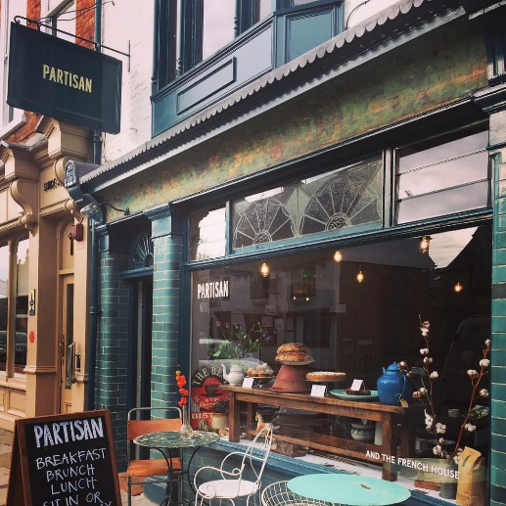

**Breakfast**

* Partisan –
  + <https://www.partisanuk.com/>
  + <https://www.instagram.com/partisanyork/>
  + Independent coffee and restaurant for **Breakfast, Brunch**, afternoon tea and Lunch
  + Reasonable prices, good hours and location
  + Info: 112 Micklegate, York YO1 6JX, phone = + 01904 629866
  + Hours 09:00 - 17:00, 18:30 - 22:00
  + Cuisine: French, European, British, Fusion, Café,
  + In the good food guide 2019
  + 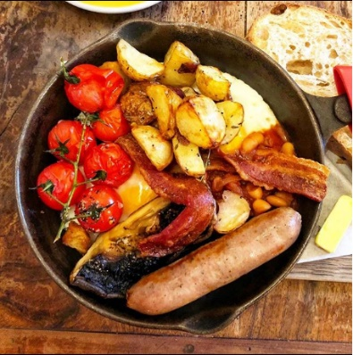[https://cdn-images-1.medium.com/max/1200/1*BdxJXQjTmmC1HTENUTwENg.jpeg](https://cdn-images-1.medium.com/max/1200/1*BdxJXQjTmmC1HTENUTwENg.jpeg)

Menu feature: i.e. Partisan Breakfast

A skillet of two fried eggs, Herb sausage, Smoked Bacon, Black Pudding, Vine Tomatoes, Mushroom, Home Fries and our home made smoky baked beans. Served with toast and butter.

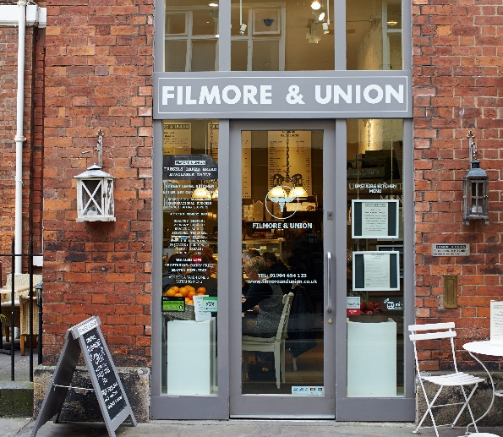

* Filmore and Union
  + <https://www.filmoreandunion.com/locations/york/>
  + <https://www.bgf.co.uk/wp-content/uploads/2017/09/6U5A6728-e1505914398751.jpg>
  + Nice all rounder, reasonably priced, large vegan menu
  + Location: 62a Low Petergate, York, YO1 7HZ
  + Opening Hours **Monday – Thursday**8am – 5pm **Friday – Saturday** 8am – 10pm **Sunday**9am – 5pm Contact T.[01904 654 123](tel:01904%20654%20123)

Menu feature: Vegan English Breakfast

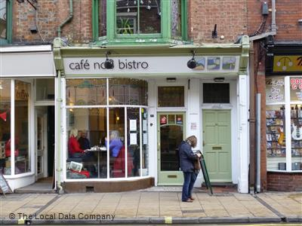

Café No.8 –

* + <https://cafeno8.co.uk/> https://twitter.com/@cafeno8
  + **Breakfast and lunch** menus
  + Average prices
  + Location: 8 Gillygate, York YO31 7EQ contact 01904 653 074
  + Hours: 2:00 - 22:00 Monday - Friday  
    09:00 - 22:00 Saturday – Sunday
  + Menu feature:
  + 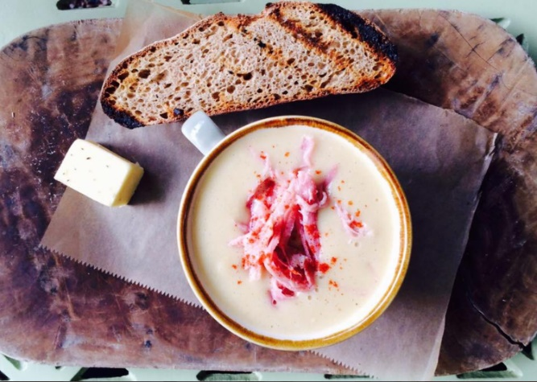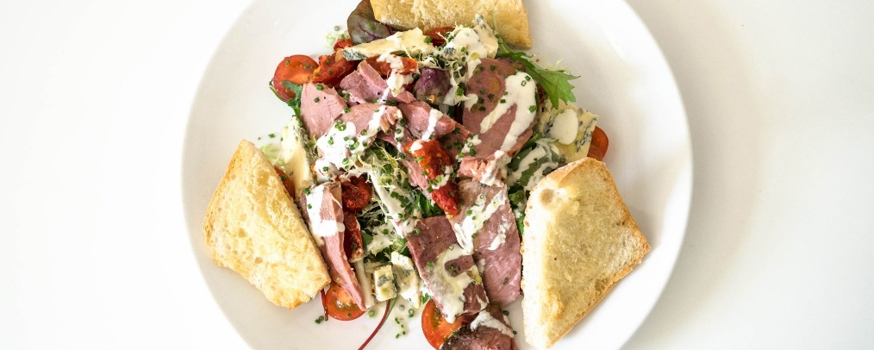Brunch menu **Roast beef open sandwich** caramelised onions, red wine gravy or Hollandaise sauce
  + **or the soup of the day**<https://cafeno8.co.uk/wp-content/uploads/2017/10/york-art-gallery13-2000x800.jpg>
  + <https://cafeno8.co.uk/wp-content/uploads/2017/09/Food-59.jpg>

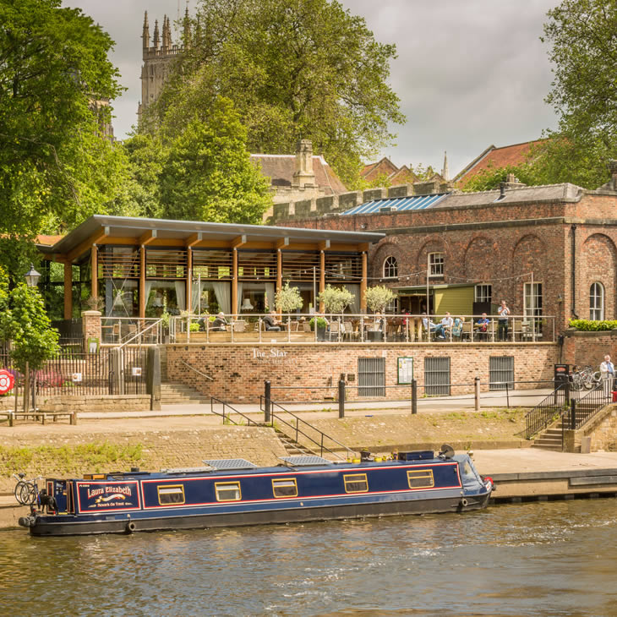

* Star Inn the city –
  + <http://www.starinnthecity.co.uk/> <https://www.instagram.com/thestarinnthecityyork/>
  + Do **breakfast** and an All day menu which changes to suit the season
  + 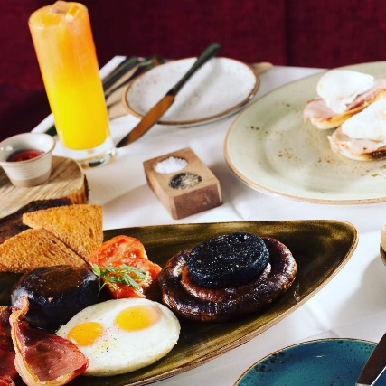Price-y better end range
  + Locations- Lendal Engine house, Museum Street, York, YO1 7DR Contacts- 01904619208
  + Breakfast 9.00am to 11.30am  
    All Day Menu noon till late
  + <https://www.yorkmix.com/wp-content/uploads/2017/04/star-inn-york-breakfast-fb.jpg>

Shortlisting:

Favourites for:

**Lunch**

* The press kitchen –
  + <https://www.thepresskitchen.co.uk/>
  + Do Breakfast **lunch** and dinner
  + Very reasonably priced, wide range of style
  + 59-63 Walmgate, York YO1 9TYTel. 01904 809 565 Open daily 8am - 11pm. Food served 8am-10pm
  + 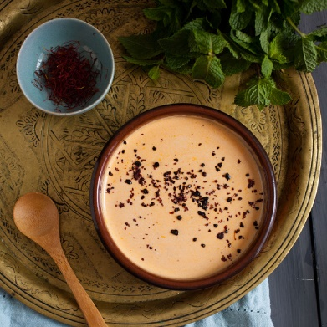
* Los Moros -
  + <https://www.losmorosyork.co.uk/>
  + A nice north African food place, has two locations in town
  + **Late Lunch**, Dinner
  + Mid range prices in store, cheaper at the food stall in the shambles
  + Open 12-10pm every day. 15-17 Grape Lane, **York**, YO1 7HU. 01904636834
* Goji
  + <http://www.gojicafe.co.uk/>
  + Vegetarian and vegan food, reasonable prices
* 36 Goodramgate, York YO1 7LF, England +44 1904 622614
  + Hours 11-16:30, 9:30 – 5pm on saturday
* 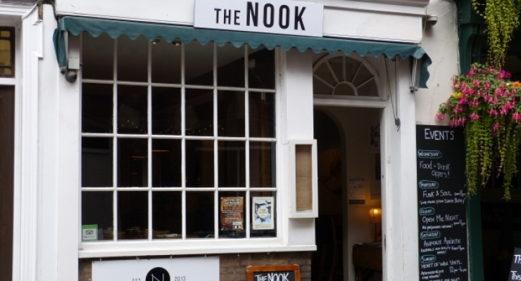The Nook-
  + <https://www.thenookyork.co.uk/>
  + World food street food kitchen style, small menu but very good prices
  + Perfect for **lunch**
* 3A Castlegate, York YO1 9RN, England
* phone: +44 1904 627122 hours: Monday – Saturday 12:00 pm - 12:00 am Sunday 12:00 pm - 11:00 pm

Shortlisting:

Favourites for:

**Dinner**

* 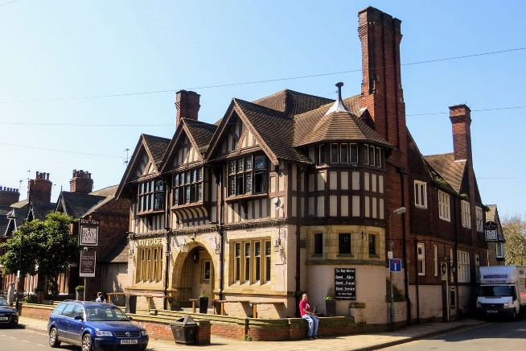Roots York
  + <https://www.rootsyork.com/> <https://www.instagram.com/rootsyork/>
  + Wide menu, great all-rounders
  + Roots York  
    68 Marygate, York  
    YO30 7BHlunch 12pm – 2pm and dinner 5.30pm – 8.30pm Wednesday – Monday. Closed Tuesday
  + Skilful
* 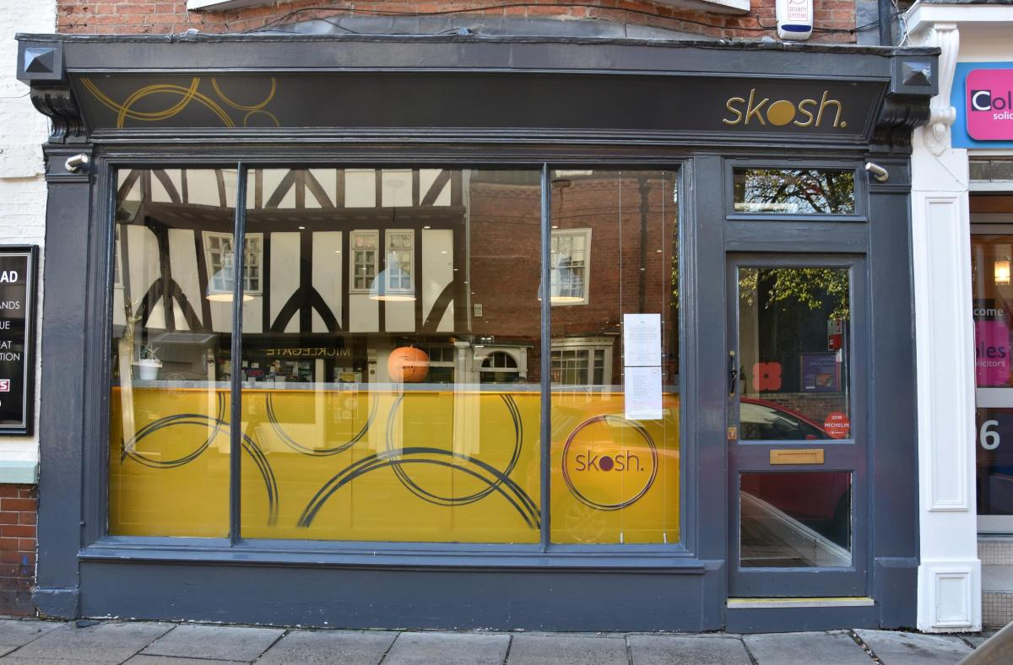Skosh –
  + <https://skoshyork.co.uk/>
  + Open kitchen concept, choose a selection of different small foods
  + Late lunch/**Early dinner** style
  + Mid to high price range
  + 98 Micklegate, **York** YO1 6JX, England, contact [01904 634849](tel:01904634849) Weds – Sat: 12pm – 2pm | 5.30pm – 10pm Sun: 12pm – 4.30pm Mon – Tues: CLOSED
  + <https://www.yorkpress.co.uk/resources/images/6996274/?type=responsive-gallery-fullscreen>
* 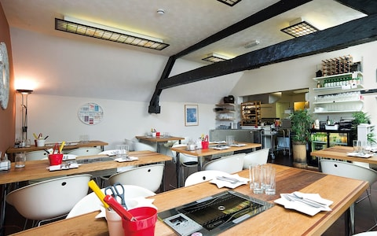Oshibi
  + <http://www.oshibi.co.uk/>
  + Korean bistro and BBQ grill , Lunch and **Dinner**
  + Reasonable prices
  + Location 9 Franklins Yard, Fossgate, York, YO1 9TA, United Kingdom, call- 01904 593649
  + Tue – Sat 17:30 to 22:00 **Lunch** 12:00 to 14:00

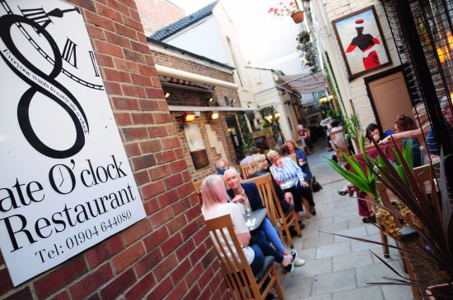

* Ate O’clock
  + <https://www.ateoclock.co.uk/>
  + Nice all rounder **dinner** place
  + Mid to high prices- 13A High Ousegate, York YO1 8RZ, England Phone: +44 1904 644080
  + 7 Days a week, 12-10pm
  + <https://media-cdn.tripadvisor.com/media/photo-s/10/eb/fa/fc/our-heated-courtyard.jpg>

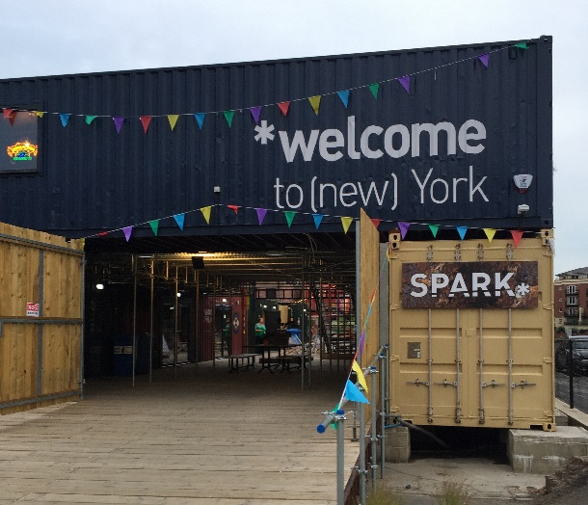

* Spark:York
  + The shipping containers at picadilly, offering a wide scene of food and drink
  + <https://www.sparkyork.org/food-drink-overview>
  + 17 - 21 Piccadilly, York, YO1 9PB, UK
  + 10 till 10 Wed to Sun

<https://foodiefriendsyork.files.wordpress.com/2018/06/img_0906-e1529182367590.jpg?w=2428&h=2087>

Shortlisting:

Favourites for:

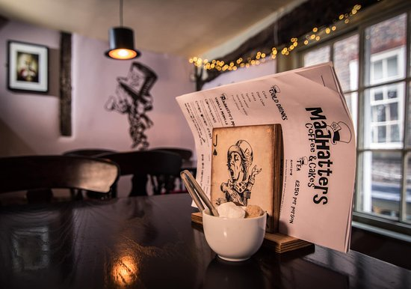**Afternoon Tea, Coffee and Desserts**

* Madhatters Coffee and cake
  + <https://www.teddybeartearooms.co.uk/>
  + Brunch and **desserts**, lots of character, a quirky place
  + Reasonably priced place
* 13 Stonegate, York YO1 8AN, England
* +44 1904 641074

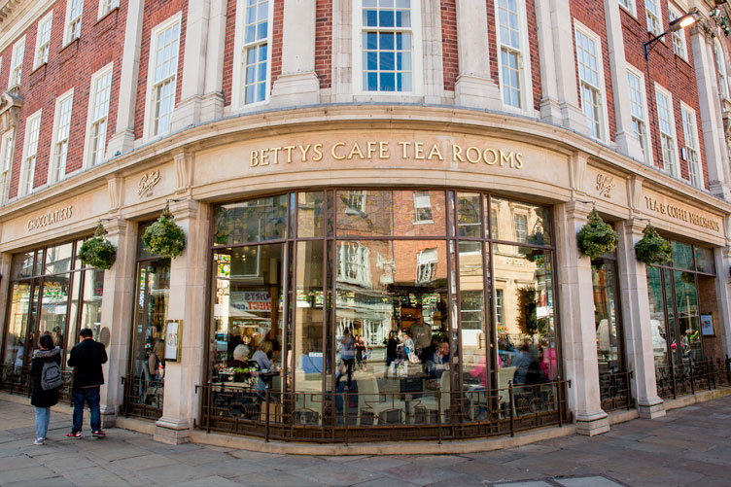

* Betty’s –
  + <https://www.bettys.co.uk/>
  + A very classic place for York, a must go
  + Afternoon tea, **dessert** place
* 6-8 St. Helens Square, York YO1 8QP, England
* +44 1904 659142
* Sun – sat 9am to 9pm
* 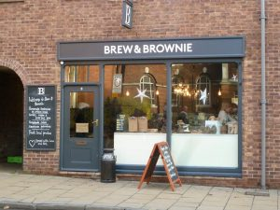Brew and Brownie
  + <https://www.brewandbrownie.co.uk/>
  + A nice café doing **breakfast and lunch** with a range of coffees or take away from their recently opened bakeshop
  + <https://www.brewandbrownie.co.uk/wp-content/uploads/2018/11/bb_shopfront-300x225.jpg>
  + 5 Museum Street, York YO1 7DT, England
  + +44 1904 647420
  + Open Mon to sat 9am -5pm
  + Sun 9:30- 4pm

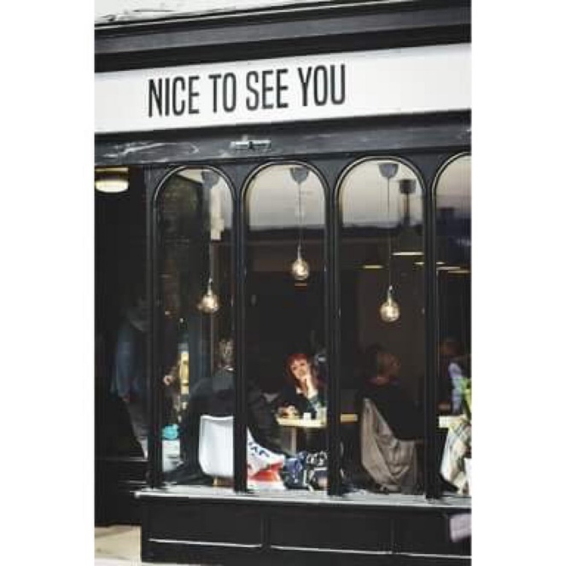Nice to see You

* + Cosy little café that do a tasty selection of treats at a reasonable price.
  + 30 Goodramgate YO1 7LG York
  + 01904 864964, Open 8am to 5 pm Mon to Sun<https://media-cdn.tripadvisor.com/media/photo-w/14/ea/0d/d2/nice-to-see-you.jpg>

<https://media-cdn.tripadvisor.com/media/photo-s/16/76/57/1a/room-1.jpg>

Honourable mentions:

* Melton’s –
  + <https://meltonsrestaurant.co.uk/>
  + Michelin star restaurant, Do lunch and **dinner**
  + Pricey high end restaurant, slightly out of town
* Kennedy’s
  + <http://www.kennedysbaryork.co.uk>
  + Breakfast lunch and Dinner, reasonable price
* Khao San Rd
  + Thai food bistro place, sister restaurant of rice style
  + <http://khaosanroadyork.co.uk/>
  + Mid-range prices, **dinner**
* Source- VEGAN.
  + <http://www.source-york.co.uk/>

Cut out listings

* Bamboo Thai takeaway
  + <http://bamboothaiyork.co.uk/>
  + Very small but a wonderful takeaway place
* Cote Brasserie
  + a chain restaurant… <https://www.cote.co.uk/>
* 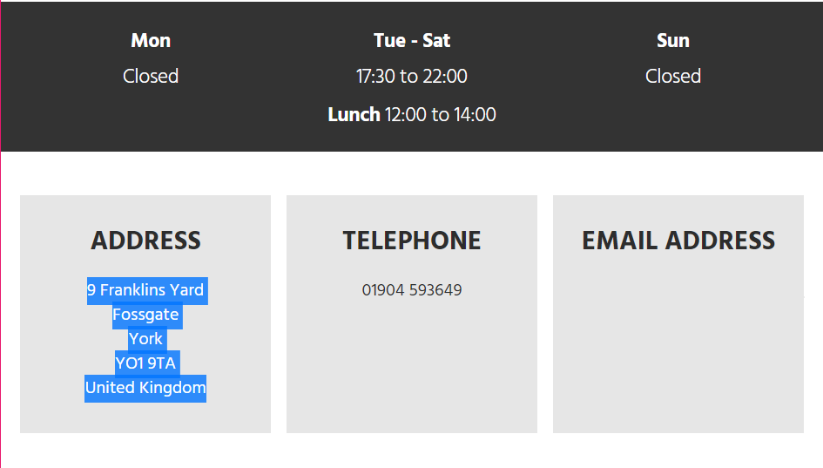Shutishuti patisserie <http://www.shutishuti.co.uk/>

List 1: Red Spotty Hanky

* Shambles kitchen
* Goji café
* The refectory
* Star Inn the city
* The judge’s Lodging
* Guy Fawkes inn x
* Bettys
* Ambiente tapas
* Filmore and Union
* Ate O’clock
* Kennedy’s
* The York roast Co.
* Brew and Brownie

List 2- Culture trip

* CAFÉ NO8 BISTRO
* D.C.H the restaurant
* The Blue bicycle
* El Piano
* Melton’s x
* Rustique
* House of trembling madness
* Nineteen

List 3- TripAdvisor

* Partisan
* Roots York
* Khao San Rd
* Madhatters Coffee and cake
* Oshibi
* The Nook
* Cote Brasserie
* Love Cheese
* Bamboo Thai Takeaway
* The press kitchen x
* Pavement Vaults
* Rice Style
* The Habit
* Happy Valley

List 4- Timeout

* Skosh
* El piano
* Melton’s
* Partisan
* Source
* Shutishuti patisserie
* Los Moros
* Spark:York (the containers at Piccadilly)
* El Piano